A Strategy to Create Stability Platforms
Soft Power in the Green Corridor

Leveraging public-private partnerships in
conflict and non-conflict environments

James Sisco and Dr Ajit Maan

hether or not India's military s lr at egy is
W
effective with regards to
the ever-present tensions in Kashmir, Pakistani border incursions,and the more general lslamist threat , is debatable.
James Sisco is president However. there is no 01ENOOO Global, debate that military action

India's Poorest 200 Districts

a risk advisory firm.
1s required to el
, ly

Or Ajit Maanls VP Research & Analysis for ENOOO Global
India.
fecllve
deal with these security challenges. But the war that rages against Maoist insurgents m India's easter n Ju ngles is different. And if changes to the current strategy are not implemented soon. there will be grave social, economic, and security consequences for all of

BAY or BENGAL

MullinationaJ corporations luel the Maoist insurgencyinthe RedCorridor throughconsistent displacement of indigenous jungle-dwelling populations to gainaccess to the region's natural resources. Iron-ore.uranium,coal, copper, gold, and diamonds are abundant ,n what is more accurately describedas the Green Corridor rather than the Red Corridor. In this Green Corridor the government forcibly acquiresland in the name of "public purpose' and then awards it to private corporalions. It ts no co1nc1dence that one of the most miltarized zones in India is also one olthe most mineral richzones.
Military hard power will not end the conflictin theGreen Corridor because MaoistInsurgents are not the origin of the problem The way forward must beled by soft power that is reinforced with

AAA IAN

LA,l(SHAOWEEP ISLAND Sclwdule V orN
200 Pootest dlSWru

INOl/1- J OCE.J\

ANDAMAN AND NICOBAR
ISLANDS

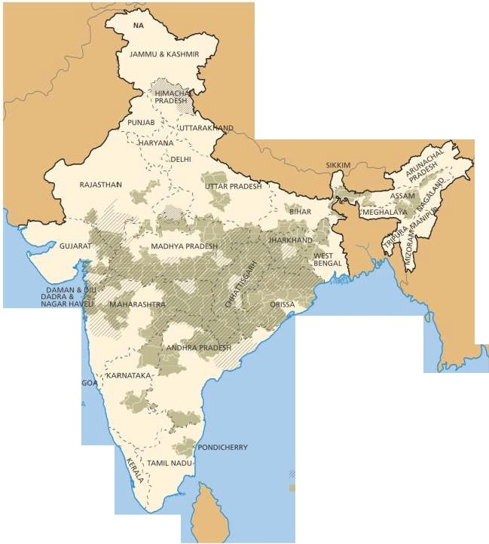stale sponsored security efforts. This was precisely theplan developed in2008 byagroupof India's fmest minds, entitled "Development Challenges In Extremist Affected Areas.' The
group found the main causes of unrest in indigenous tribalcommunities were attributed to Inequity, deprivation, and failure of the state to safeguard the rights, Iands, and well-being of its
citizens asguaranteed under theconstitution.
The recommendations 1dentilied 1n the report were never implemented.They weredisregarded as a result of thegovernment's partnershipwith

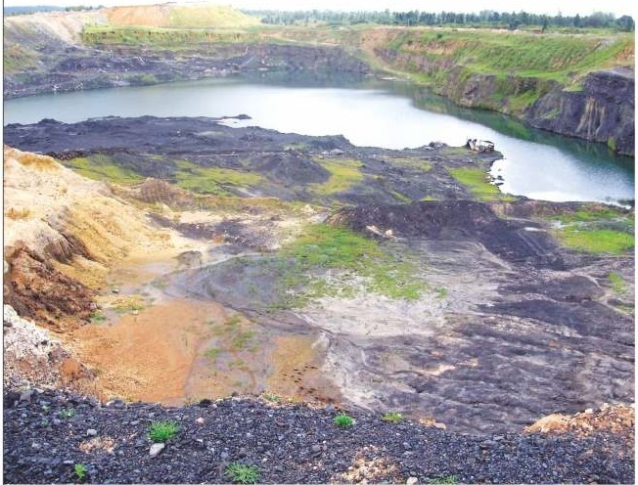

Iron ore strip miningsite

the private sector. In fact, when environmental concerns and rights of the tribal communtties were addressed by the Supreme Court's expert committee, Juslice Kapadia-without denying lhe committee's f indings-announced in open court that he held sharesin Sterlite and therefore gave clearance for Sterhte to continue mining operations. It is no wonder that the indigenous population sees analliance between government andindustry to acquire their land andits natural resources by displacing"relocating" them.
A successful strategylo combat insurgents
and create stable operating environments for multinational corporations mus! locus on soft power initiatives-lhrough public and private partnerships-that address local community needs and objectives. Small-scale, grass-roots development proJects provide themost effective waylo involve localstakeholder-disenfranchised and discriminated groups that include dalits. tnbals. and women-which are most susceptible to insurgent influence. These tailored pro1ects avoid the pitfalls associated with large-scale. lop-down development and provide an immediate benefit lo communities affected by
mullinationalcorporations.
Soft power development programs should be butlressed by hard power security initiatives. Rather thantargeting suspected insurgents. hard power protects development pro1ects that serve locals thereby garnering popular support among communities, and undermining insurgent propaganda. These activities should be reinforced with narratives that are part of a comprehensive communications strategy. The narratives should tell astory in the oral tradition of the community that will shape the perceptions of all those Involved. Narratives wdl ground t11ese

"The failure of the government to enforce the constitutionally protected (5th schedule) rights of the Adivasi people and their land has increased the widespread distrust of the government and industry alliance."
successes 1nthe community'sidentity.
There are numerous examples of successful alignment programs between NGOs, governments . and local communities in mutually beneficialcollaborative efforts. One success story is that of the NGO PRADAN (Professional Assistance for Developmental Action). PRADAN collaborated with the Ministry of Rural Development. the Department of Agriculture, the Ministry of Textiles, and women's groups. In what was initially set uptobe micro financialassistance lo help rural communities Improve their water supply,women in the community helped map the watershed, change crop patterns. and replace annual crops with perennials This resulted in an increase of water supply, crop production, and a reducllon In soilerosion. Theextent of the results was unexpected. In collaboration with governmental agencies. indigenous women became integral to the resilience of rural agricultural systems. environmental stewardship,
andpohhcalaction
Women and other marginalized groups in conflict zones have tremendous potential to bring security and stability to their communities.The government has previously recognized the need to coordinate efforts with locals and specified the involvement of local women. In 1992 the 73rd amendment to the constitution institutionalized the ancient practice of panchayat (a system in whichvillagerselectelders amongthem to govern local aflairs). The amendment granted elected elders power to implement development programs in their areas with one-third of those positions reserved for women.
Theway forward istocreate stability platforms through social alignmentinitiatives between local communities. government agencies and private sector companies. The existingstrategy.and hard power tactics only reinforce Maoist support and undermine development initiatives in the restive Green Corridor.To achieve success, government agencies and private sector companies must understand the basic needs of each community and assist inthe fulfillment of those needs.
Providing basic needs like access to clean
water, electricity and educationlo communities mitigates insurgent influence In the Green Corridor and allows the government to growIts presence. Government sponsored development projects should be designed and Implementedin collaboration with existing private company and NGOs programs to share costs and optimize delivery of goods and services. When coordinated with local community leaders and marginalized groups,development projects create pockets of stability that reduceprotests,work stoppages and violence. Furthermore, such engagements will generate legal and transparent revenue from mining corporations for the government and safeguard acompany's bottom line.
Within the nexus of politics and private investment, an etfective media strategy is key to creating enduring partnershipswithinindigenous communities. Local and national media Involvement wlll demonstrate lo other Indian communities, regional governments. and multinational corporations how this alliance is a modelof sustainability and cooperation for mutual benefit. The narrativethat supports theseefforts is oneof cooperation and mutualbenern.
With the eyes of theinternational community
upon them. India's government and multinational corporations have the opportunity to implement a socially responsible strategy that focuses on aligning the ob1ectives of the 1nd1genous tribal communities with government and private sector interests. A soft power strategy provides the most direct and effective way to mitigate Maoist lnlluence. create pockets of stability for private investment , and improve the lives of disadvantaged Individuals and indigenous communities. Such strategies have been successful in conflict and non-conflict environments across lhe globe and can aid lhe Indian government and multinational corporationsoperating In the Green Corridor. It is theonly strategy thatwilldeliver long-termstability andprofitability.

